Context Diagram

Level 0: system context
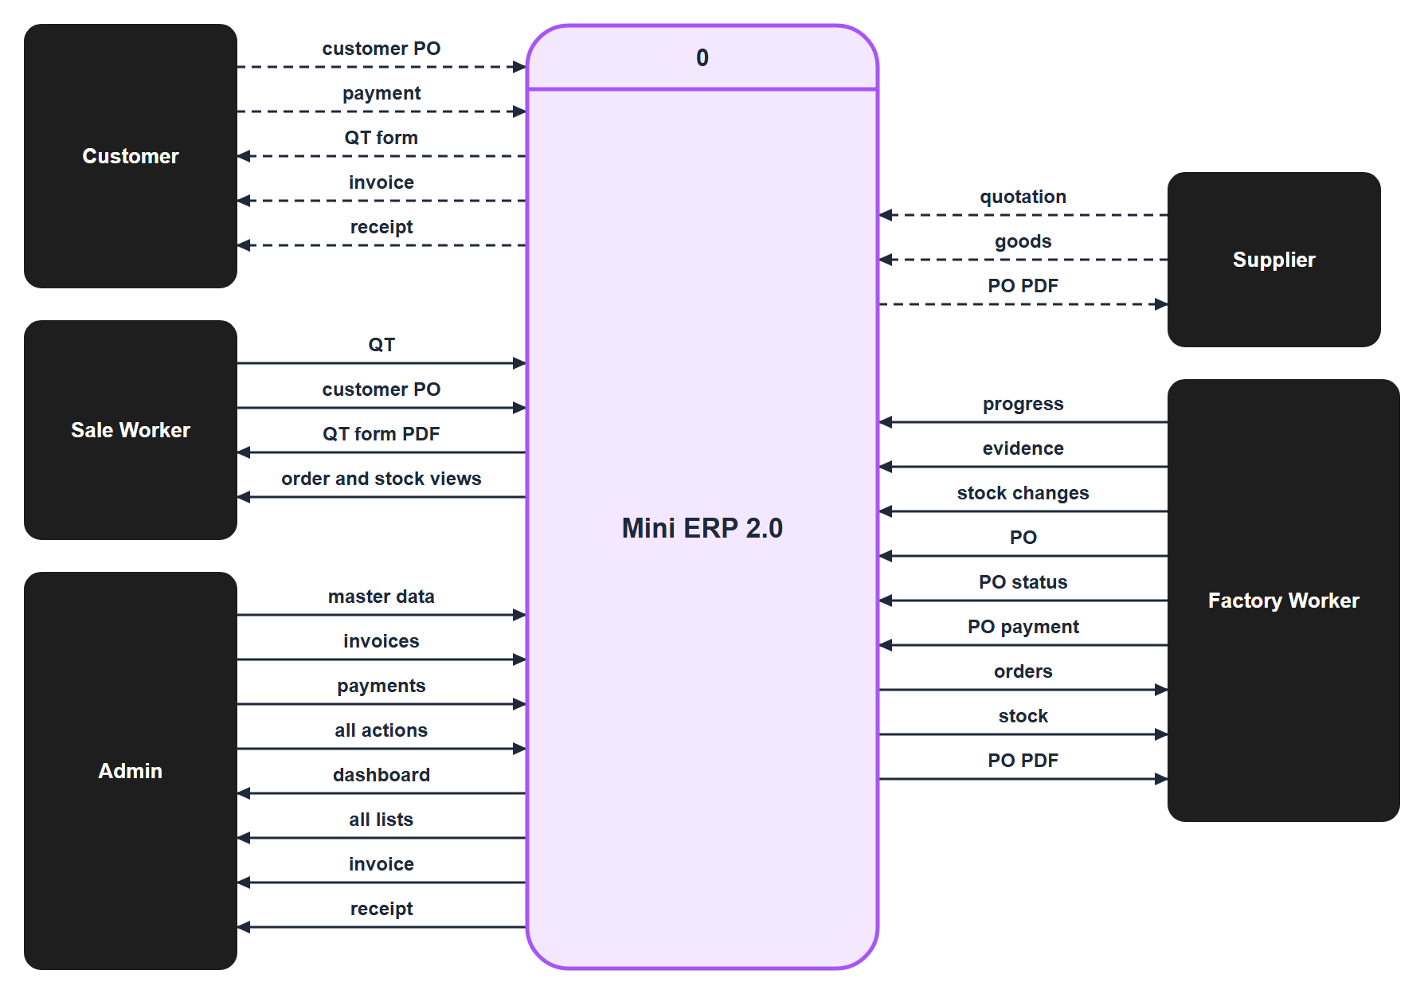
Figure 1. Level 0: system context (data flow diagram; dashed lines: handed over by users)

Level 1: inside the system
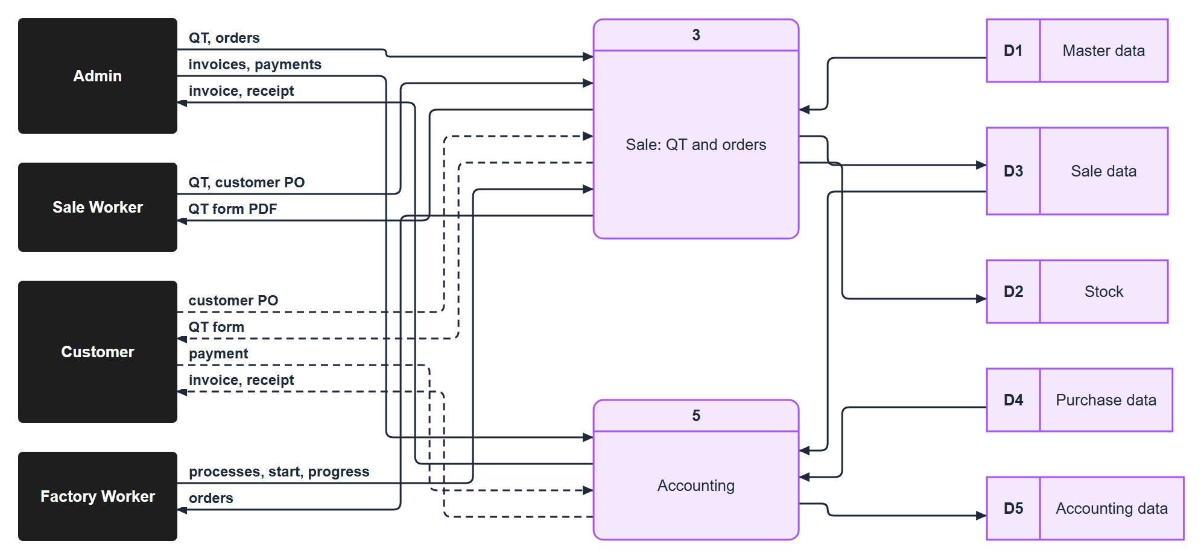
Figure 2. Level 1: Sale and accounting (processes 3 and 5)
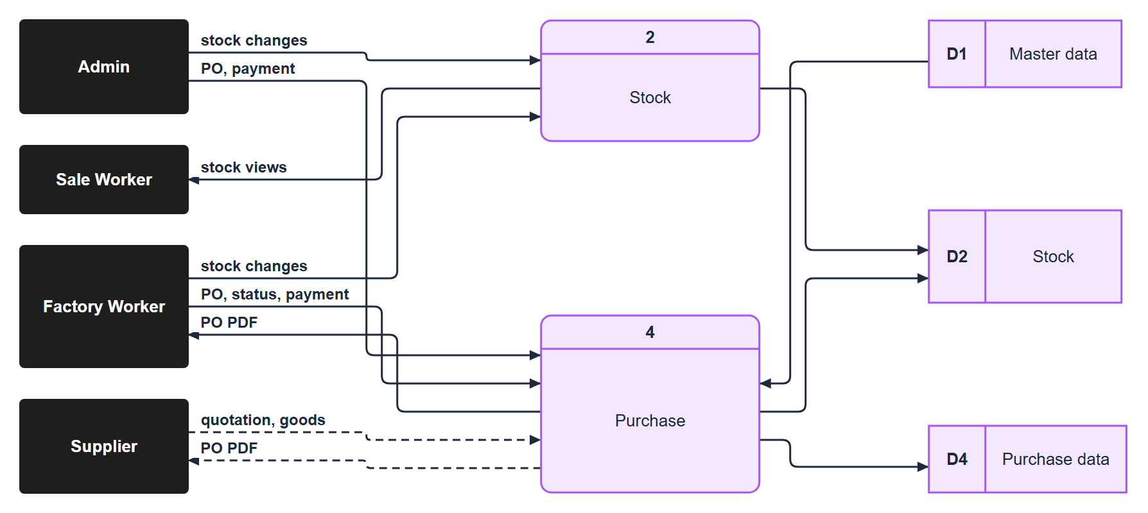
Figure 3. Level 1: Stock and purchase (processes 2 and 4)
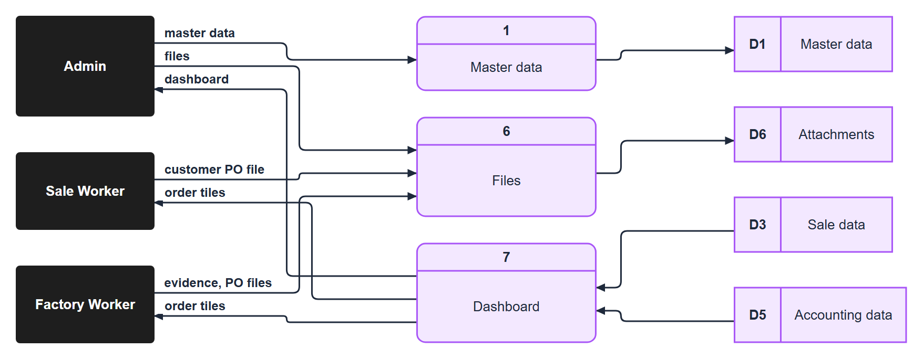
Figure 4. Level 1: Master data, files and dashboard (processes 1, 6 and 7)
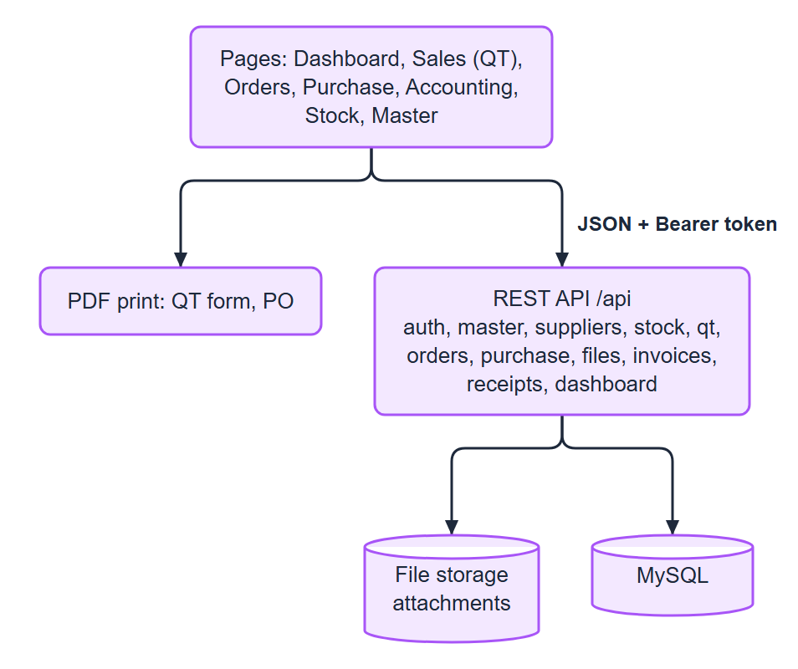
Figure 5. Level 1: architecture (frontend: pages, PDF print; backend: REST API, file storage, MySQL)

External entities
Entity | Gives the system | Gets from the system
Admin | master data, invoices, payments, any action | all pages, invoice and receipt
Sale Worker | QT, customer PO file | QT form PDF, order and stock views
Factory Worker | progress, evidence files, stock changes, PO and its status and payment | orders, stock, PO PDF
Customer (outside) | customer PO, payment | QT form, invoice, receipt (handed over by users)
Supplier (outside) | goods, quotation | PO PDF (handed over by the user)

Data stores added in Version 2.0
Store | Content
Purchase data | suppliers, supplier items and prices, POs, PO lines, PO payments
Attachments | PO files, quotations, production evidence, other documents

Not in this system
Sales orders, delivery, supplier invoices, serial numbers and tax. (The Accounting page also lists the received purchase orders that wait for payment and the ones that are paid; the payment is recorded on the PO.)

